Joint circular from Central Trade Unions to the state chapters of CTUs
and to Sectoral Federations and Associations

22nd July, 2020

National Platform of Central Trade Unions along with Sectoral federations and Associations calls upon working class to observe 9th August as “SAVE INDIA DAY” CTUs & other PSUs to observe Solidarity Actions on 18th August on Coal Strike Day

The joint Platform of Central Trade Unions met on 8th July and then again on 18th July along with sectoral federations & associations to plan next course of agitations. The meeting took note that the working class under the banner of Central Trade Unions and the Sectoral Federations and Associations observed Nationwide Protest Day on 3rd July 2020, as a massive success throughout the country, in all workplaces and centres as a united struggle of Non-Cooperation and Defiance to anti-worker, anti-farmer, anti-people and anti-national policies of the Govt. The action programmes were organised in almost one lakh places in the states in the work places, union offices, on roads & streets including processions, cycle and motorbike rallies, public meetings.
The Joint Platform of Central Trade Unions, independent sectoral Federations and Associations congratulated the coal workers who successfully held strike for three days, on 2nd-3rd-4th July 2020 bringing the coal mines and establishments under Coal India and SCCL to grinding halt with no production and no dispatch of coal. Strike was called to oppose and resist the Government decision to completely privatise the coal sector through unregulated commercial mining of coal and trading by private sector including foreign entities much to the detriment of national interests and self-reliance. The coal unions have once again decided to go on strike on 18th August 2020- the last day of bidding for allotment of coal blocks for private commercial mining.

The meeting noted that with the opening up of some industrial units, all workers are not being taken back, only a small percentage is finding their place back in jobs and that also on reduced wages and refusal to pay lockdown period salary. Such denial of employment, and pressing for wage-reduction have to be unitedly combated. The recent decision of Air India authorities to give notice to 20000 employees to go on leave without pay for six months, including the provision of compulsory (forced) leave without pay, which may get extended to 5 years. This is grossly violative of the existing statutes.

The jobless are more than 14 crore and if we add the daily wagers/contract/casual, it is more than 24 crores who are out of livelihood at present. The MSMEs themselves are reporting that 30% to 35% units may not be in position to start their activities. The unemployment rate is high. ILO has said in its report that more than 40 crore people would be pushed into deeper poverty. That the malnutrition would increase, hunger deaths would become a daily reality, and there is real threat of depression resulting in suicides amongst workers say the eminent scientists & medical experts. All these issues are enraging workers.

The meeting once again reiterated the stand of CTUs that the Government not only failed in taking necessary steps to contain the pandemic in time having wasted four precious months, imposed unplanned lockdown with short notice bringing in severe miseries to the people specially the migrant labour, failed in taking essential steps for upgrading health system and providing the safety equipments to front line warriors, it not only failed to recognise the immense services provided by employees of Railways, Defence, Banks, Insurance, Telecom, Postal and other sector providing essential services during lockdown period, but did not address the problems they faced, it faultered in dealing with the problem of COVID-19 as law & order issue instead of treating it as medical emergency for the human beings and society. It has caused immense miseries to millions of workers, farmers and other vulnerable sections of the society, whereas, Government stood only by the Corporates & big businesses.

The CTUs reiterated their opposition to disinvestment and wholesale privatisation of Public Sector Enterprises, entry of FDI in core sectors up to the tune of 100 per cent - Indian railways, Defence, Port and Dock, Coal, Air India, Banks, Insurance including of Privatisation of Space Science & Atomic Energy etc., Public sector banks, insurance and other financial sectors are also being targeted for large-scale privatisation. Steps in favour of Corporates of Indian & Foreign brands to usurp natural resources and business of the country while mouthing the slogan of Aatma-Nirbhar Bharat are being pushed through shamelessly. The decision of DA freeze of 48 lakh Central Government Employees and DR freeze of 68 lakh pensioners, which is also having impact on the state government employees, is not withdrawn despite vehement opposition from Government employees and CTUs. Neither the demand of cash transfer of Rs.7500/- to all non-income tax paying persons accepted. The govt. having failed in getting its own orders in regard to payment of lockdown period wages, no retrenchments and no cut in wages shamelessly withdrew its own order in the Supreme Court of India when some Employers went to court against these orders.

The Government continues with its arrogant attitude of going ahead with privatisation and sale of PSUs, and dangerously liberalizing foreign entry in vital sectors of the economy like defence production from 49 to 74% along with corporatization of 41 ordnance factories for privatization; it is also going ahead with its project of privatizing Indian Railways in phases, the latest being its destructive decision of privatizing 151 train services in highly remunerative routes to facilitate private players to make huge profit using infrastructure and manpower of Indian Railways. The policy of surrendering of sanctioned posts and ban of creation of new jobs in various government departments continues in detriment to the young aspirants for jobs. On the top of it the continuous price-rise in petrol & diesel made effective on 22 occasions in the last two months is another big blow to the people.

A Government which has no respect and concern, towards the rights and basic survival-entitlements of workers and the people, does not deserve any co-operation. We the workers/employees and trade unions need to do everything possible to be in solidarity with each other, unitedly face the disease taking all precautions necessary, stand with each other to defend our rights of unionization, collective bargaining, decent working condition, wages & future securities etc. This Govt has demonstrated cruel insensitivity of the basic human needs of the workers and people. This cannot be endorsed and cooperated with.

Hence the united platform of Central Trade Unions and Federations/Associations called upon to step up the struggles against the anti-people, anti-worker policies of the Govt both on sectoral and national level with continuity. It was decided that;
- On 9th August –the “Quit India Day” should be observed as “Save India Day” through countrywide stayagraha/jail bharo-or any other form of militant agitations in all workplaces/ industrial centres/district headquarters and rural areas etc.
- On the day of coal workers strike on 18th August 2020, militant solidarity actions in all workplaces and the PSUs in particular; possibility of strike action should be explored wherever is possible.
- The defence sector unions/federations have been jointly planning to give notice for strike on the basis of the strike ballot approved by more than 99 per cent workers. They may go for strike action sometimes in mid September 2020. The united platform of CTUs and federations conceived the idea of countrywide general strike against the policies of the Govt. synchronising with the defence sector strike and called upon all concerned to start preparation in that direction.
- It is noted that the Scheme workers unions/federations (Anganwadi, ASHA, Mid Day Meal etc) have jointly decided to go in for two days strike on 7th and 8th August 2020 which will converge with countrywide satyagraha/jail bharo/agitation on 9th August 2020. The joint meeting of CTUs and federations called upon all concerned to express solidarity with the Scheme workers strike action.
- It has also been decided to continue countrywide campaign against the Govt. move on Railway privatization in coordination with the unions/federations with the Railway Sector and also independently. Railway Federations reported that they are also planning and preparing for their response/actions at appropriate time.
- It was agreed that the petition to President of India as a campaign which is circulated among CTUs will be finalized after receiving suggestions and then starting it as change.org campaign. Another suggestion was taken on board to initiate another petition to focus on specially unorganised sector workers’ problems. It was also decided that the Platform of CTUs will once again meet on 27th July for detailed discussion on preparations of 9th August program to make it effective and visible.
We call upon all the state chapters of CTUs to conduct their meetings inviting the sectoral federations and associations to plan about the next phase of agitation, and take the exercise to districts and enterprise/industry level.
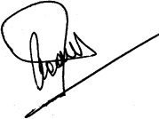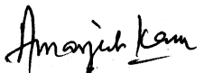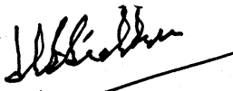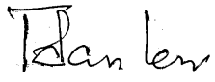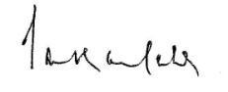
INTUC AITUC HMS CITU AIUTUC
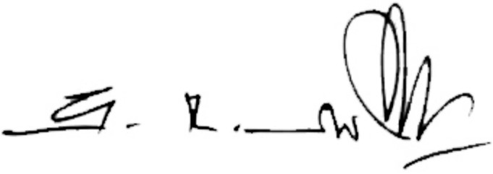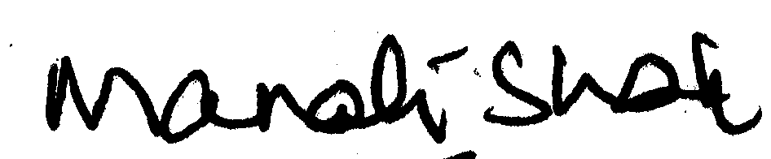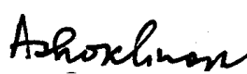
TUCC SEWA AICCTU LPF UTUC
And Sectoral Federations and Associations

